Integrating with Enterprise Information Systems
The J2EE Connector architecture addresses the problem of integrating Java enterprise applications with existing Enterprise Information Systems (EIS). An EIS can be a system such as ERP, CRM, and supply chain management applications and database systems. Previously, if an enterprise application had to access information in an EIS, some one had build a custom connection between the application server and the EIS.
Now the J2EE Connector architecture defines a uniform way to integrate J2EE application servers with existing information systems. Each EIS vendor creates a resource adapter using this architecture. A resource adapter is much like a JDBC driver, as both provide a standard API through which an application can access a resource that is outside the J2EE server. This resource adapter plugs into a J2EE compliant application server. As long as the resource adapter follows the Connector specification, it provides a scalable, secure, and transactional connection to an application server.
To use a resource adapter for an application server, you can use JBuilder's Connector Module wizard, which creates the deployment descriptors for the resource adapter. Then you use the Connector DD Editor to provide the information the resource adapter needs to make the connection to the EIS.

Creating a connector module
To create a connector module that contains a resource adapter, follow these steps:
- Choose File|New|Enterprise and double-click the Connector Module (RAR) wizard.
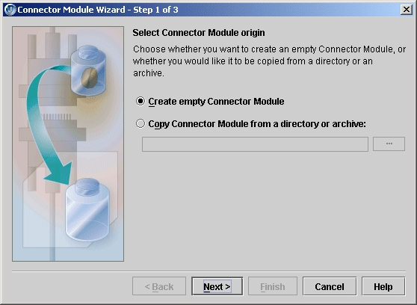
- Decide whether you are creating an empty connector module, which you will fill in later, or if you are copying an existing connector module from a directory or archive. Make your choice by selecting the corresponding option. If you are copying a connector, use the ellipsis (…) button to browse to the connector module's location.
- Click Next to go to the next page of the wizard.
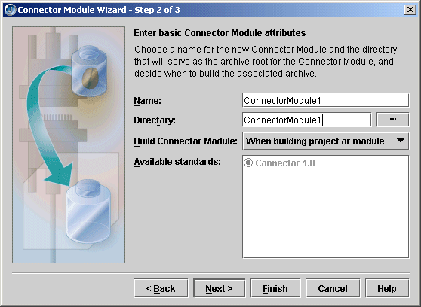
- Specify a meaningful name for the module in the Name field.
- Use the Directory field to specify where you want the connection module located. By default, JBuilder puts it in a directory with the same name as that of the module.
- Select a build option from the drop-down list in the Build Connector Module field.
- Click Next.
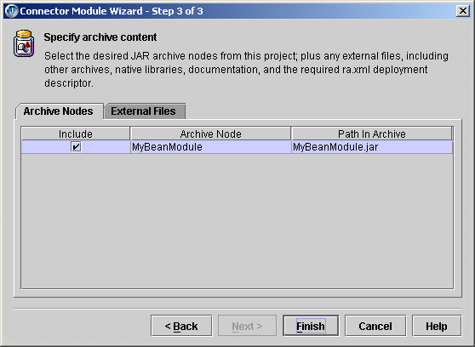
- Check the Include check boxes of the modules existing in your project that you want included in the connection module on the Archive Nodes page.
- If you want to include files other than other archives, click the External Files tab and use the Add button to navigate to the files you want to add. You might include such files as libraries, documentation, other archives, or whatever you need.
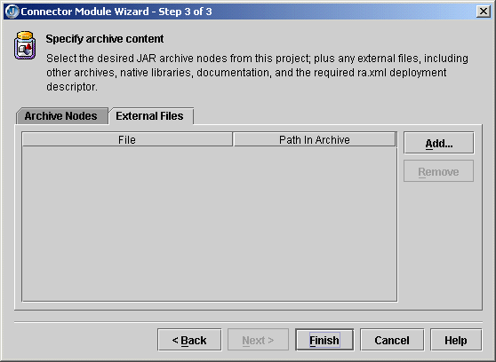
- When you have added all modules and files you want to the connector module, click Finish.
A new connector module node appears in the project pane. Double-click it to see the Connector DD Editor appear:
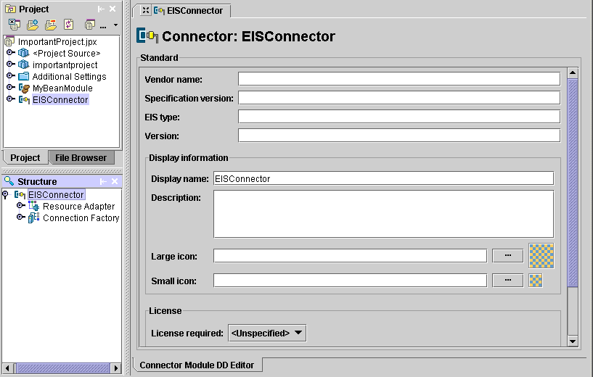
Fill in the fields on the Connector page in the Connector DD Editor. These are the fields:
- Vendor Name: Enter the name of the EIS vendor.
- Specification Version: Specify the Connector specification version being used.
- EIS Type: The type of EIS, which helps identify which EIS instances the connector can be used with.
- Version: Specify the version of the resource adapter being used.
- Display Name: Specify a short name that can be displayed in a GUI.
- Description: Use this field to include any information that the component file producer wants to provide to the deployer. This information is optional.
- Large Icon: Specify a JPEG or GIF file containing a small image (16x16 pixels) to be used in a GUI. This information is optional.
- Small Icon: Specify a JPEG or GIF file containing a small image (32x32 pixels) to be used in a GUI. This information is optional.
- License Required: Use the drop-down list to specify whether a license is required or not.
- Description: If a license is required, this field specifies the licensing requirements for the resource adapter module. For example, you might include the duration of license, number of connection restrictions, and so on. This information is optional.

Editing the resource adapter descriptors
By looking in the structure pane, you'll see that your connector module contains a resource adapter node. Other nodes that you may see are server-specific nodes, so which nodes appear depends on your server.
You must supply the information requested on the Resource Adapter page. Fill in the following fields:
- Managed Connection Factory Class: Specify the class that implements the ManagedConnectionFactory interface, which either matches an existing connection to the EIS with the incoming request or creates a new physical connection to the EIS. When the application server needs a connection to the EIS, it asks this class to retrieve an existing connection or create a new one.
- Connection Factory Interface: Specify the ConnectionFactory interface, which allows an application component to connect to an EIS instance.
- Connection Factory Implementation Class: Specify the class that implements the ConnectionFactory interface. This class will contain a getConnection() method that requests the application server to allocate a connection using the ConnectionManager.allocateConnection() method.
- Connection Interface: Specify the Connection interface, which connects an application with the EIS.
- Connection Implementation Class: Specify the class the implements the Connection interface. This class must include a close() method so the application can terminate a connection with the EIS.
- Transaction Support: Use the drop-down list to specify whether the connection will have No Transaction Support, Local Transaction Support, or XATransaction Support. Local transactions are managed internally by the EIS. XA transactions are managed by a transaction manager external to the EIS.
- Supports Reauthentication: Check this field if you want the resource adapter to support reauthentication.
For more information about resource adapters and the J2EE Connector Architecture, see these articles on the web:
- "The Java 2, Enterprise Edition (J2EE) Connector Architecture's Resource Adapter" at http://developer.java.sun.com/developer/technicalArticles/J2EE/connectorclient/resourceadapter.html
- "What's New in the J2EE Connector Architecture 1.5" at http://developer.java.sun.com/developer/technicalArticles/J2EE/connectorarch1_5/
- "J2EE Connector Architecture" at http://java.sun.com/j2ee/connector/.
- "J2EE Connector Architecture" at http://java.sun.com/j2ee/tutorial/1_3-fcs/doc/Connector.html, which is part of Sun's J2EE Tutorial.
Expand the resource adapter node in the structure pane to see three category subnodes: Authentication Mechanisms, Configuration Properties, and Security Permissions. To add a new node of any of these types, right-click the node and choose Add.

Authentication Mechanism page
If you add a Authentication Mechanism page, it looks like this:
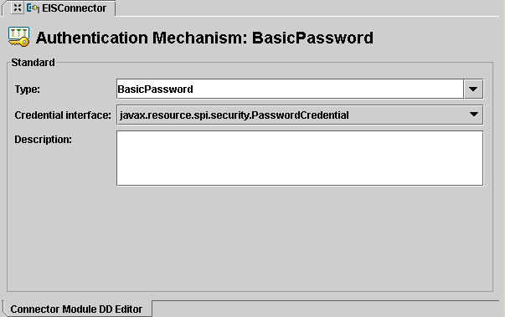
These are the fields on this page:
- Type: Use the drop-down list to specify the type as BasicPassword or Kerbv5, meaning a Kerboros version 5 authentication mechanism.
- Credential Interface: Use the drop-down list to specify the interface. If you chose the BasicPassword type, select the PasswordCredential interface, which encapsulates a user name and password. If you chose the Kerbv5 type, select the GenericCredential interface, which defines a way to access the security credentials of a Principal.
- Description: Use the optional Description field to specify any resource adapter specific requirement for the support of security contract and authentication mechanism.

Configuration Property page
If you add a Configuration Property page, it looks like this:
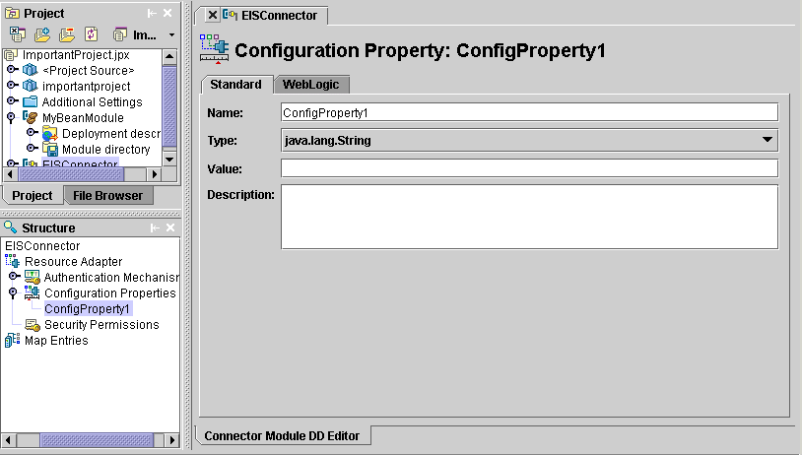
These are the fields on this page:
- Name: Specify the name of the configuration property.
- Type: Specify the type of the configuration property by using the drop-down list.
- Value: Specify the value of the configuration property.
- Description: Describe the configuration property.

Security Permission page
If you add a Security Permission page, it looks like this:
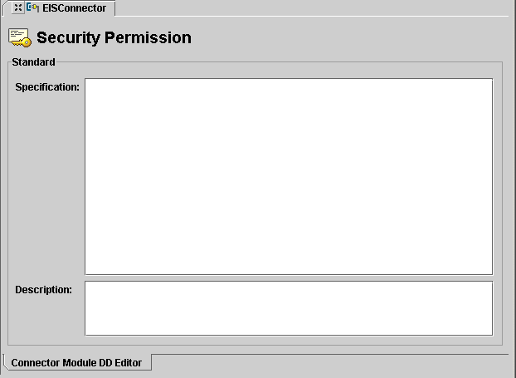
These are the fields on this page:
- Specification: Specifies a security permission that is required by the resource adapter code.
- Description: An optional description.

Server-specific pages
As you work with pages in the Connector DD Editor, you may find server-specific pages. To get help for these pages, press F1. Your server documentation should also be a good source of information about the type of data your server requires.
Some servers have a server-specific node in a connector module that is not a part of the resource adapter. For example, here you see a Map Entries node in the structure pane, which appears if your selected server is WebLogic 8.x:
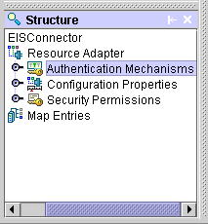
Again, if you need help with the pages linked to a server-specific node, press F1 and also consult your server's documentation.

Compiling the connector module
When you successfully compile a connector module, a RAR (resource archive) is created.
To compile a connector module, right-click the module in the project pane and choose Make.
To see the resulting RAR, expand the connector module node in the project pane:
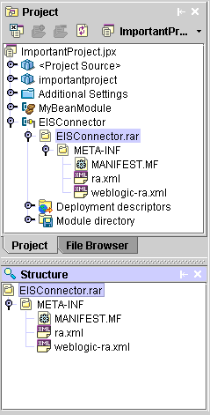
You can also expand the RAR node to see the RAR's deployment descriptors. Double-click a deployment descriptor to see it in its XML format. If there are errors in the resulting XML file, the Errors folder in the structure pane will tell you what the problems are.

